
Name & Surname: _______________________________________ Class: _______
Grade 4 & 5 2025 # 29 Hand in by Thurs 25 Sept
Kirsten has written numbers into 5 of the 10 circles. She wants to write numbers into the remaining circles so that the sum of the three numbers along every side of the pentagon is always the same.
Which number does she have to write into the circle marked X?
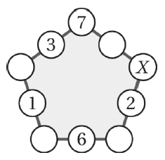
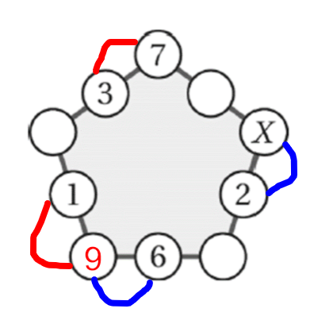
$X+2=9+6$
$∴X=13$

