Name & Surname: _______________________________________ Class: _______
Grade 4 & 5 2021 # 33 Hand in by Thurs 11 Nov
3 more problems
1. Find the value of $a+b+c+d$ if:

$a×b=30$
$b×d=40$
$c×d=56$
$b×c=35$
Trial and improvement: $a=6, b=5, d=8, c=7$
Therefore, $a+b+c+d=26$
2. If 8♦$=$6♥ and 6♠ $=$ 3♥. How many ♠ do you need to equal 12 ♦?

♦ ♥ ♠
8 6 12
$×3$ 24 18 36
$÷2$ 12 9 18

Therefore, 12♦$=$18♠

3. In a stable there are men and horses. In total there are 24 heads and 68 legs in the stable. How many men are there in the stable?

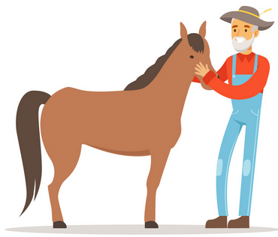
men + horses = 24

A bit of trial and improvement will get you to the answer of
14 men and 10 horses

