
Name & Surname: _______________________________________ Class: _______
Grade 6 & 7 2026 # 1 Hand in by Thurs 22 Jan
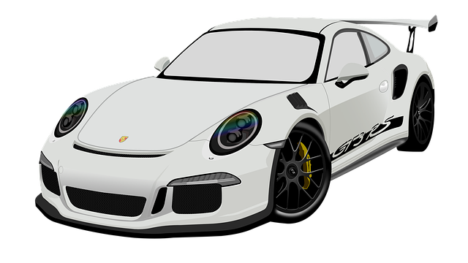
You, in your new red Porsche, decide to make a 160km trip to Hermanus, travelling at 80km/hr. You make the return trip travelling at a rate of 48km/hr. What was your average speed for the entire trip?

Solution
We need to work out the total distance travelled and the total amount of time spent travelling.
$\frac{160km}{80km/h}$ =2 hours
$\frac{160km}{48km/h}=\frac{20}{6}=\frac{10}{3}=3\frac{1}{3}hours$
Thus, the total distance is 320 km and the total time taken is $5\frac{1}{3}$ hours.
Using a calculator to work out $320÷5\frac{1}{3}=320÷5,3333333=60$ km/h

