

Name & Surname: _______________________________________ Class: _______

Grade 4 & 5 2025 # 24 Hand in by Thurs 21 August

1. Chloe chose a three-digit integer with all its digits different and wrote it on lots of pieces of paper.

Peter picked some of the pieces of paper and added the three-digit integers on them. His answer was 2331.

How many pieces of paper did Peter pick?

Therefore Peter picked up 9 pieces of paper

1. Elijah painted each of the eight circles in the diagram red, yellow or blue such that no two circles that are joined directly were painted the same colour.

Which two circles must have been painted the same colour?

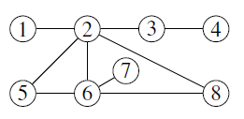

Since no two circles that are joined directly are painted the same colour and circles 2, 5 and 6 are joined to each other, they are all painted different colours. Similarly circles 2, 6 and 8 join to each other and hence are painted different colours. Therefore circles 5 and 8 must have been painted the same colour. It is easy to check that, given any other pair of circles in the diagram, it is possible for them to be coloured differently.