

Name & Surname: _______________________________________ Class: _______

Grade 4 & 5 2025 # 27 Hand in by Thurs 11 Sept

1. A train has 12 carriages. In each carriage there is the same number of compartments. Jack is sitting in the 18th compartment behind the engine, and this is in the 3rd carriage. Pippa is sitting in the 50th compartment behind the engine, and this is in the 7th carriage.

How many compartments are in one carriage?

If there were 6 compartments per carriage, then the 18th compartment would be in the 3rd carriage, but the 50th compartment would be in the 9th carriage.

If there were 7 compartments per carriage, then the 18th compartment would be in the 3rd carriage, but the 50th compartment would be in the 8th carriage.

If there were 8 compartments per carriage, then the 18th compartment would be in the 3rd carriage, and the 50th compartment would be in the 8th carriage.

If there were 9 compartments per carriage, then the 18th compartment would be in the 2nd carriage.

Thus, there are 8 compartments per carriage.

1. 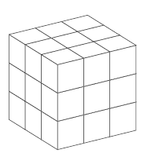The 3×3×3 cube consists of 27 small cubes.

Some of the small cubes are removed. If you now look at the cube from the right, from above and from the

front, you see the following:

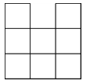

How many little cubes were removed?

7