

Name & Surname: _______________________________________ Class: _______

Grade 6 & 7 2025 # 19 Hand in by Thurs 26 June

Gerard cuts a large rectangle into four smaller rectangles. The **perimeters** of three of these smaller rectangles are 16, 18 and 24, as shown in the diagram.

What is the perimeter of the fourth small rectangle?

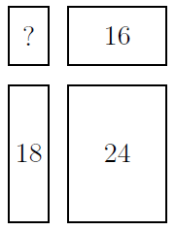

From the diagram, it can be seen that the perimeter of the rectangle in the top left and

the perimeter of the rectangle in the bottom right together are equal to the perimeter of the large rectangle. The same argument is true for the perimeter of the rectangle in the bottom left and the perimeter of the rectangle in the top right. Therefore 24 + ? = 18 + 16 and hence ? = 10.