
Name & Surname: _______________________________________ Class: _______
Grade 6 & 7 2026 # 3 Hand in by Thurs 5 Feb

Three rectangular-shaped holes have been drilled passing all the way through a solid $3×4×5$ rectangular prism. The diagrams show the front, side and top views of the resulting block.
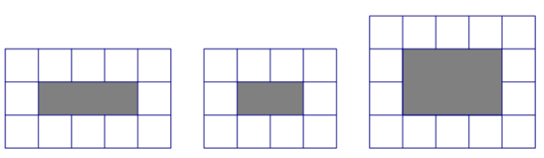
What fraction of the original prism remains?

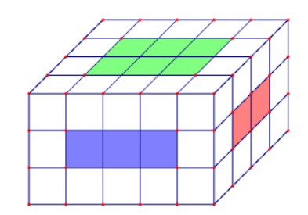
The drilled part which is common to all three holes consists of $2×3=6$ cubes
Plus there will be extra cubes for each colour hole which are on the faces:
Blue: $\left(3×1\right)×2=6$
Red: $\left(2×1\right)×2=4$
Green: $\left(3×2\right)×2=12$
Thus, there will be $6+6+4+12=28$ cubes removed, which means that
$5×4×3-28=32$ cubes remain, so the fraction remaining is $\frac{32}{60}=\frac{8}{15}$

