
Name & Surname: _______________________________________ Class: _______
Grade 6 & 7 2026 # 2 Hand in by Thurs 29 Jan
A set of cards has a shape on once side and a colour on the other side.
The rule is: If a card has a circle on one side, then it must have blue on the other side.
Here are four cards.
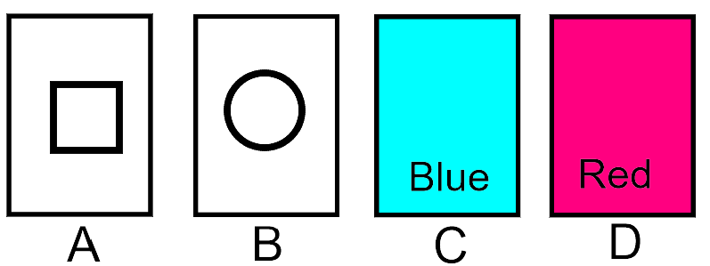
If you want to check that the rule is being followed, what must you do?
- Turn over any single card
- Turn over card A and one other card
- Turn over cards B and C
- Turn over cards B and D
- Turn over cards B, C and D

Solution
A does not have to be turned over; it doesn’t matter if the other side is blue – the rule applies only if we can see a circle
B must obviously be turned over
C does not have to be turned over; any shape can have blue on the other side
D must be turned over; if there is a circle on the other side, then the colour side must be blue

