
Name & Surname: _______________________________________ Class: _______
Grade 4 & 5 2025 # 31 Hand in by Thurs
A 5 by 5 by 5 cube is formed using identical 1 by 1 by 1 cubes.
Fifteen columns of cubes are then removed, five from front to back, five from top to bottom, and five from side to side. The columns that are removed are indicated by the shaded squares in the following diagram of the cube.

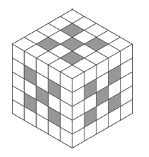
How many of the 1 by 1 by 1 cubes are left?

When removing columns from the front to the back, 5 smaller cubes are removed from each
layer. A total of 25 cubes are removed during this stage.
When removing cubes from top to bottom, since some cubes have already been removed with the front to back columns, the number of cubes removed from each layer is no longer the same.
From top to bottom, the number of cubes removed from each layer is 5, 1, 4, 1, and 5. Thus,
16 additional cubes are removed during this stage.
Finally, when removing cubes from side to side, the number of cubes removed at each layer is 5, 1, 4, 1, and 5, the same as the number removed in going from top to bottom. Thus, a total of 16 additional cubes are removed during this final stage.

The total number of cubes removed is 25 + 16 + 16 = 57. The original 5 by 5 by 5 cube had
5 x 5 x 5 = 125 of the smaller 1 by 1 by 1 cubes. Therefore, there are 125 $-$ 57 $=$ 68 cubes
remaining.

