

Name & Surname: _______________________________________ Class: _______

Grade 6 & 7 2025 # 20 Hand in by Thurs 24 July

Sam wants to complete the diagram so that each of the nine circles contains one of the digits from 1 to 9 inclusive and each contains a different digit.

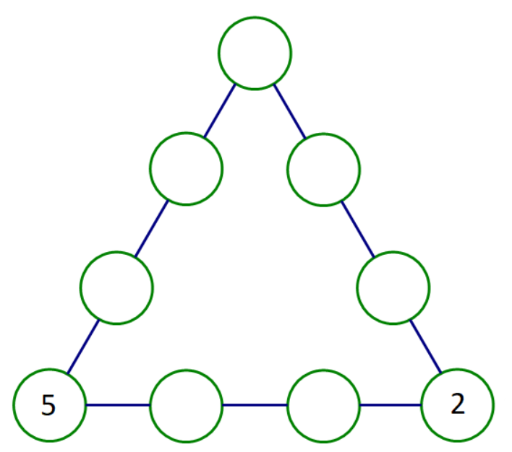

Also, the digits in each of the three lines of four circles must have the same total.

What is this total?

The numbers in the corners are counted twice when adding the three lines together. Because 2 and 5 have already been placed in the corners, it follows that the totals of the three lines will be

. When adding three equal numbers together, the sum will be a multiple of 3. Thus, could be 54 or 57 or 60. Because the 2 and 5 have already been used, the total will have to be 60, which means that the top corner will have to be 8.

Thus, the numbers could be filled in as follows:

